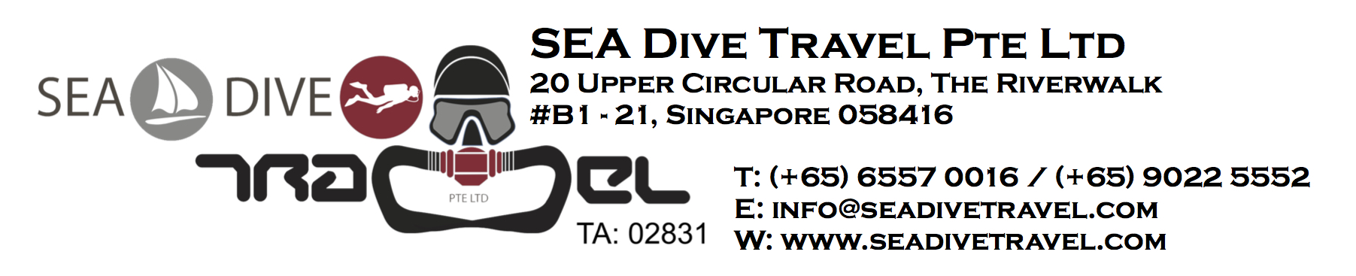
LIABILITY RELEASE FORM (the "Release")
I ___________________________, hereby declare that I am a certified scuba diver / trainee diver trained in safe diving practices / non-diver (delete where applicable), and I am aware of the inherent risks and hazards of skin and scuba diving ("Diving") and/or participating in the Dives (hereinafter defined).
IN CONSIDERATION OF being allowed to participate in the Dives:
- I understand, agree and undertake to assume any and all such inherent risks and hazards of the proposed dive trip to _______________ ("Dive Site") from the period __________to __________, which may be conducted onboard a boat or may require travel onboard a boat or any other vehicle (hereinafter referred to as the "Dives"), which include but are not limited to, the following:
- (applicable only to certified scuba divers and trainee divers) Diving with compressed air involves certain inherent risks that may result in injuries such as decompression sickness, embolism or other hyperbaric injuries which require medical support and/or treatment in a decompression chamber. I further understand that the Dive Site may be remote from a decompression chamber or medical support. I still choose to proceed with the Dives in spite of the possible absence of a decompression chamber or medical support in proximity to the Dive Site;
- the Dives involve inherent and/or unforeseeable risks that may include, but are not limited to, drowning, slipping or falling while onboard a boat, sinking of the boat, injuries occurring while getting on or off a boat, loss of personal belongings and equipment, equipment failure, injuries inflicted by marine life form, acts of fellow divers and other perils of the sea; and
- (applicable only to certified scuba divers and trainee divers) Diving is a physically strenuous activity and that I will be exerting myself during the Dives and that I may be injured as a result of a heart attack, panic, hyperventilation, overexertion or any other cause.

- I declare, undertake and agree:

- to personally assume all risks in connection with the Dives, whether foreseeable or unforeseeable, and RELEASE and HOLD HARMLESS Sea Dive Travel Pte. Ltd. (the “Company”), Friendly Waters Seasports Pte. Ltd., the certified dive guide at the Dive Site, and any of its employees, officers, servants, agents or assigns (hereinafter referred to as "Released Parties") from any liability, claim or lawsuit arising, directly or indirectly, from any of the above-mentioned risks, or from any harm, injury or damage or loss that may befall me while I am a participant of the Dives, to the extent permitted under the laws of Singapore;
- to further RELEASE and HOLD HARMLESS the Released Parties from any liability, claim or lawsuit arising, whether under the express or implied terms of this Release or at common law, or in any other way, or from any loss or damage of whatever nature and howsoever arising out of or in connection with the Dives, to the extent permitted under the laws of Singapore;
- that I have adequate health, medical and emergency evacuation insurance coverage that is sufficient to cover even catastrophic injuries in countries other than in Singapore. I further undertake to fully indemnify the Released Parties against any and all costs and expenses that may be incurred in connection with the materialization of any of the above-mentioned risks, including but not limited to, the cost of evacuation, hospital and physician charges and charges relating to treatment in a decompression chamber;
- (applicable only to certified scuba divers and trainee divers) that I am in good mental and physical fitness for Diving and that I am not, and will not be under the influence of alcohol or any drugs that are contradictory to Diving. If I am taking any medication, I declare that I have seen a physician and have obtained approval from my physician to dive while under the influence of medication;
- (applicable only to certified scuba divers and trainee divers) that I will inspect all my equipment prior to every use and will notify the Released Parties if any of my equipment is not working properly. I will not hold the Released Parties responsible for my failure to inspect my equipment prior to diving;
- that I am of lawful age and legally competent to sign this Release or have attached the written consent of my parent or guardian to this form;
- that I fully understand the terms herein are contractual and not mere recital, and that I have signed this document on my own free will;
- that if any term contained herein shall be held to be illegal, invalid or unenforceable, in whole or in part, under any enactment or rule of law, such term or part shall to that extent be deemed not to form part of this Release but the legality, validity or enforceability of the remainder of this Release shall not be affected; and
- that this Release shall be binding upon my family, estate, heirs, successors and assigns and shall be governed by and construed in accordance with the laws of Singapore.

- I understand that pursuant to Regulation 21, Travel Insurance of Travel Agents Regulations, I am to consider purchasing travel insurance:
- against any failure or disruption in the Company’s provision of the travel product arising of insolvency on the Company’s party; and
- in favour of all travellers for whom any payment or deposit is to be made.

I further understand and acknowledge the risk if I do not purchase travel insurance against insolvency.

I have fully informed myself of the contents of this Release by reading it before I sign on behalf of myself and my heirs.

In the case of an emergency, please contact:

Name:_____________________________ Tel:___________________________ Relationship:___________________________

___________________________________ ___________________________________
Participant’s Name (as per Passport) Date

___________________________________ ___________________________________
I/C / Passport No. Signature of participant

___________________________________ ___________________________________
Guardian’s Name / Signature Date

