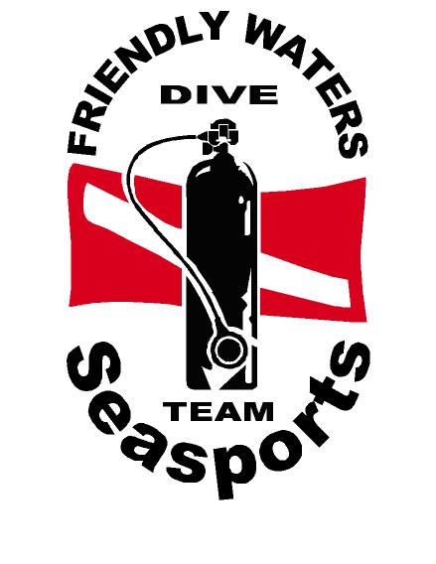
FRIENDLY WATERS

SEASPORTS PTE LTD

RAID OPEN WATER DIVER COURSE

Photograph
(Passport Size)

Kindly complete form in BLOCK letters

Name: _______________________________________

Tel: _______________ Mobile: ________________

Email: _______________________________________

D.O.B: ____________ Passport No: ________________

Address: _____________________________________

_____________________________________

ISSUED
- MANUAL : _____________ SCHE/MTH:_________________

- DEPOSIT : _____________ Training Code :_____________

- BALANCE :______________ CLASS :_________________

- FULL PAYMENT : _____________ O.W TRIP :_________________

POOL 1 : _________________

Makeup Pool :______________

BCD: _________ REG: _________ SUIT: _________ FINS: _________ MASK: _________

